Project Design Phase-II
Data Flow Diagram & User Stories

Date | 19 February 2026
Team ID | LTVIP2026TMIDS77295
Project Name | Smart Sorting: Transfer Learning for Identifying Rotten Fruits and Vegetables

Data Flow Diagrams:
A Data Flow Diagram (DFD) is a traditional visual representation of the information flows within a system. A neat and clear DFD can depict the right amount of the system requirement graphically. It shows how data enters and leaves the system, what changes the information, and where data is stored.
Example: DFD Level 0 (Context Diagram) Example: DFD Level 1 (Detailed Diagram)
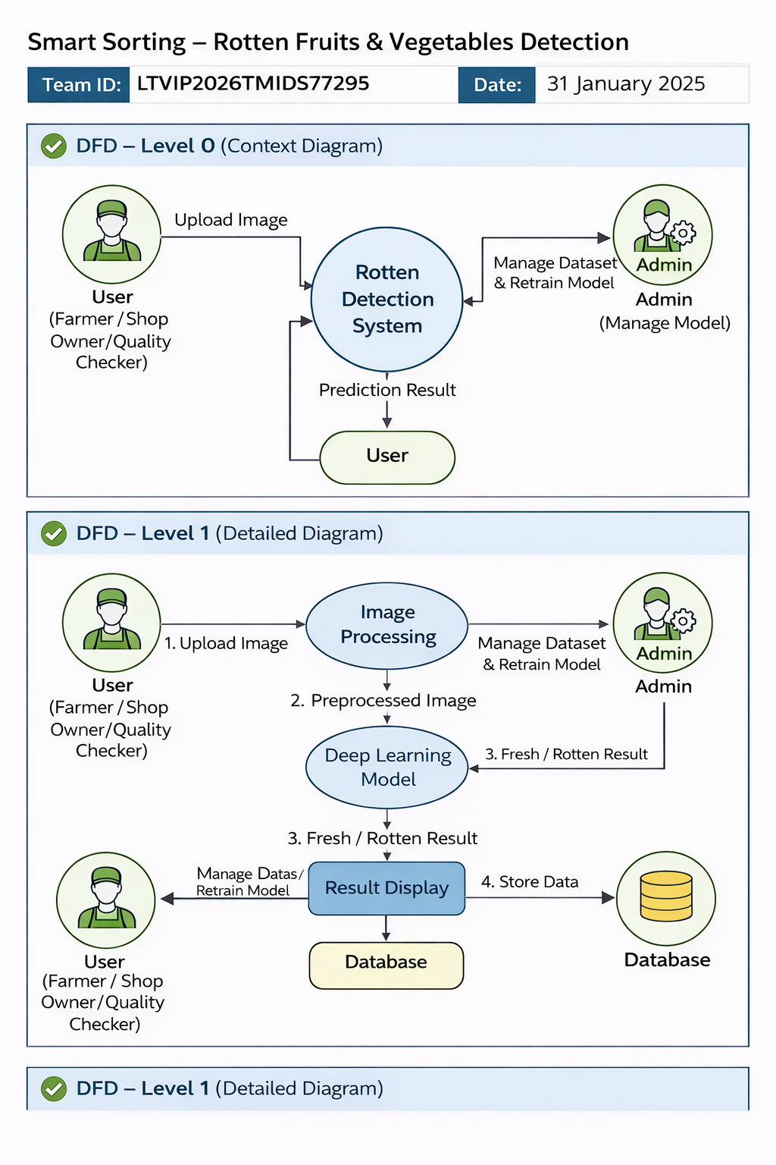
User Stories
Use the below template to list all the user stories for the product.
User Type | Functional Requirement (Epic) | User Story Number | User Story / Task | Acceptance criteria | Priority | Release
Visitor | View home page | USN-1 | As a visitor, I can open the home page to know what Smart Sorting does. | Home page shows title, tagline, and navigation links. | High | Sprint-1
Visitor | Navigate to other pages | USN-2 | As a visitor, I can click navbar links (Home, About, Predict, Contact). | Correct page (about/predict/contact) opens without error. | High | Sprint-1
Visitor | View project overview | USN-3 | As a visitor, I can read how Smart Sorting uses AI to detect rotten produce. | Text explains goal, approach, and benefits clearly. | High | Sprint-1
Visitor | View model statistics | USN-4 | As a visitor, I can see model accuracy, number of classes, and dataset size. | Cards show 94.6% accuracy, 4 classes, 3200 images (or updated values). | High | Sprint-1
Visitor/Customer | Open prediction page | USN-5 | As a user, I can open the Predict page to upload an image. | Upload form with file chooser and submit button is visible. | High | Sprint-1
Visitor/Customer | Upload image | USN-6 | As a user, I can upload a fruit/vegetable image for analysis. | Image is saved to uploads/ without server error. | High | Sprint-1
Visitor/Customer | See classification result | USN-7 | As a user, I can view whether the item is Fresh or Rotten with a confidence score. | Result page shows label (Fresh/Rotten), confidence %, and image preview. | High | Sprint-1
Visitor/Customer | Handle missing file | USN-8 | As a user, I get a clear message if I submit without selecting an image. | Same page reloads with message “Please upload an image.” | Medium | Sprint-1
System | Serve uploaded images | USN-9 | As the system, I must serve uploaded images so they can be shown on the result page. | Image is returned correctly and displayed in <img> tag. | High | Sprint-1
Visitor | View contact / team details | USN-10 | As a visitor, I can open the Contact page to see how to reach the project team. | Page shows team ID, team members and contact info (email or form). | Medium | Sprint-2
Admin/Developer | Load trained model | USN-11 | As a developer, I can load the trained healthy_vs_rotten.h5 model when the app starts. | Model loads without error; predictions use latest weights. | High | Sprint-1
Admin/Developer | Update model & metrics | USN-12 | As a developer, I can retrain the model and update accuracy, classes, dataset size in About. | About page reflects new metrics; predictions match new model behaviour. | Medium | Sprint-2

